SDMX STANDARDS: SECTION 7

GUIDELINES FOR THE

USE OF WEB SERVICES

Version 2.1

April 2011

© SDMX 2011

http://www.sdmx.org/

Contents

1 Introduction 1

2 Web Services and SDMX-ML 1

3 SOAP-Based SDMX Web Services: WSDL Operations and Behaviours 3

3.1 Introduction 3

3.2 The SDMX Web-Services Namespace 3

3.3 Support for WSDL Operations 3

3.4 List of WSDL Operations 3

* 3.4.1 Data 3
* 3.4.2 Metadata 4
* 3.4.3 Structure usage 4
* 3.4.4 Structure 4
* 3.4.5 Item scheme 5
* 3.4.6 Other maintainable artefacts 5
* 3.4.7 XML Schemas (XSD) 6
* 3.4.8 Generic query for structural metadata 6

3.5 Other Behaviours 6

* 3.5.1 Versioning Defaults 6
* 3.5.2 Resolving References and Specifying Returned Objects 6
* 3.5.3 Enabling compression 6
* 3.5.4 Implementation of the SOAP based SDMX Web Services 6
* 3.5.5 Compliance with WS-I 7

4 SDMX RESTful API 7

4.1 A Brief Introduction to REST 7

4.2 Scope of the API 7

4.3 Structural Metadata Queries 8

* 4.3.1 Resources 8
* 4.3.2 Parameters 9
* 4.3.3 Examples 12

4.4 Data and Metadata Queries 13

* 4.4.1 Resources 13
* 4.4.2 Parameters 13
* 4.4.3 Examples 17

4.5 Schema queries 18

* 4.5.1 Resources 18
* 4.5.2 Parameters 18
* 4.5.3 Examples 19

4.6 Selection of the Appropriate Representation 20

4.7 Enabling data compression 21

5 Standard Errors for SDMX Web Services 21

5.1 Introduction 21

5.2 Error handling in REST Web Service 21

5.3 SOAP Web Service 21

5.4 Error categories 21

5.5 Client-Caused Errors 22

* 5.5.1 No results found – 100 22
* 5.5.2 Unauthorized – 110 22
* 5.5.3 Response Too Large Due to Client Request 130 22
* 5.5.4 Syntax error – 140 22
* 5.5.5 Semantic error – 150 22

5.6 Server-Caused Errors 22

* 5.6.1 Internal Server Error – 500 22
* 5.6.2 Not implemented – 501 22
* 5.6.3 Service unavailable – 503 23
* 5.6.4 Response size exceeds service limit - 510 23

5.7 Custom Errors – 1000+ 23

5.8 SDMX to HTTP Error Mapping 23

6 Annex: Examples 24

6.1 Sample Queries for a Web Services Client 24

* 6.1.1 Step 1: Browsing an SDMX data source, using a list of subject-matter domains 24
* 6.1.1.3 Request using the SOAP API 24
* 6.1.2 STEP 2: Selecting a dataflow 25
* 6.1.2.3 Request using the SOAP API 26
* 6.1.3 STEP 3: Data selection 28
* 6.1.3.3 Request using the SOAP API 28

6.2 Sample Error Element in an SDMX message 30

6.3 Soap Fault example 31

# Introduction

Web services represent the current generation of Internet technologies. They allow computer applications to exchange data directly over the Internet, essentially allowing modular or distributed computing in a more flexible fashion than ever before. In order to allow web services to function, however, many standards are required: for requesting and supplying data; for expressing the enveloping data which is used to package exchanged data; for describing web services to one another, to allow for easy integration into applications that use other web services as data resources.

SDMX, with its focus on the exchange of data using Internet technologies provides some of these standards relating to statistical data and metadata. Many web-services standards already exist, however, and there is no need to re-invent them for use specifically within the statistical community. Specifically, SOAP (which originally stood for the “Simple Object Access Protocol”) and the Web Services Description Language (WSDL) can be used by SDMX to complement the data and metadata exchange formats they are standardizing. In the web services world, the REST (“Representational State Transfer”) protocol is also often used, relying on a URL-based syntax to invoke web services. Such REST-based services can be described in a standard fashion using WADL (“Web Application Description Language”), in the same way that XML-invoked web services based on SOAP can be described using WSDL.

Despite the promise of SOAP and WSDL, it became evident from early implementations by vendors that these were not, in fact, interoperable. It was for this reason that the Web Services - Interoperability (WS-I) initiative was started. This consists of a group of vendors who have all implemented the same web-services standards the same way, and have verified this fact by doing interoperability tests. They publish profiles describing how to use web services standards interoperably. SDMX uses the work of WS-I as appropriate to meet the needs of the statistical community.

This document provides several SDMX-specific guidelines for using the existing standards in a fashion which will promote interoperability among SDMX web services, and allow for the creation of generic client applications which will be able to communicate meaningfully with any SDMX web service which implements these guidelines.

Much of the content of this document is not normative – instead the intention is to suggest a best practice in using SDMX-ML documents and web services standards for the exchange of statistical data and metadata. However, the SDMX WSDL and WADL files that formalise, in XML, the APIs described in this document are normative.

# Web Services and SDMX-ML

Conventional applications and services traditionally expose their functionality through application programming interfaces (APIs). Web services are no different – they provide a public version of the function calls which can be accessed over the web using web-services protocols (SOAP or REST). In order to make a set of web services interoperate, it is necessary to have a standard abstraction, or model, on which these public functions are based. SDMX benefits from having a common information model, and it is a natural extension to use the SDMX Information Model as the basis for standard web-services function calls.

Web services exchange data in an XML format: this is how the data passed between web services is formatted. SDMX-ML, as a standard XML for exchanging data and structural metadata within the statistical realm, provides a useful XML format for the public serialization of web-services data. While there are some techniques for simple web-services data exchanges – remote procedure calls (RPCs) – which are often used, the use of a set of XML exchanges based on a common information model is seen as a better approach for achieving interoperability.

There are several different document types available within SDMX-ML, and all are potentially important to the creators and users of SDMX web services.

The "Structure" Message: This message describes the concepts, data and metadata structure definitions, and code lists which define the structure of statistical data and reference metadata. Every SDMX-compliant data set or metadata set must have a data or metadata structure definition described for it. This XML description must be available from an SDMX web service when it is asked for.

The "Generic" Data Message: This is the "generic" way of marking up an SDMX data set. This schema describes a non-data-structure-definition-specific format for exchanging SDMX data, and it is a requirement that every SDMX data web service makes its data available in at least this form. It is expected that, in many instances, other data-structure-definition-specific XML forms for expressing data will also be supported in parallel services.

The "Structure Specific" Data Message: This is a standard schema format derived from the structure description using a standardized mapping, and many standard tags. It is specific to the structure of a particular data structure definition, and so every data structure definition will have its own "structure specific" schemas. It is designed to enable the exchange of large data sets, This is a data format that a web service may wish to provide, depending on the requirements of the data they exchange.

The "Query" Messages: This is the set of messages used to invoke SOAP-based SDMX web services. These messages all conform in a consistent way to a master template, but are decomposed into specific queries to allow each service to support only those fields in the template message which are meaningful to it. These query messages are generic across all data and metadata structure definitions, making queries in terms of the values specified for the concepts of a specific structure (as specified in a structure description). It allows users to query for data, concepts, code lists, data and metadata structure definitions.

The “RegistryInterfaces” Message: All of the Registry Interfaces are sub-elements of this SDMX-ML Message type. They are more fully described in the SDMX Registry Specification.

The “Generic” Metadata Message: This is a message used to report reference metadata concepts, which is generic across all types of reference metadata structural descriptions.

The “Structure Specific” Metadata Message: This is a message used to report reference metadata concepts specific to a particular metadata structure definition.

# SOAP-Based SDMX Web Services: WSDL Operations and Behaviours

## Introduction

This section addresses the operations and behaviours specific to SOAP-based Web Services. Most important is a list of standard WSDL operations, which will form the basis of, and be accompanied by, actual standard WSDL XML instances, for use in development packages. There are also several guidelines for the implementation of web services, to support interoperability.

All SDMX SOAP web services should be described using WSDL instances. The global element for each XML data and metadata format within SDMX should be specified as the content of the replies to each exchange. The function names for each identified pattern are specified below, along with the type of SDMX-ML payload.

Because SOAP RPC is not supported, the “parameters” of each function are simply an instance of the appropriate SDMX-ML message type. As noted above, <wsdl:import> should be used to specify the schema for a multiple-message exchange. The distributed WSDL files illustrate how SOAP messages should be used.

## The SDMX Web-Services Namespace

The SDMX Web Services namespace[1] contains a set of messages specific to the use of SOAP-based services. Each of the operations described will have a message to invoke the Web-Service, and a response message. In each case, these are refinements of other SDMX messages, appropriate to the operation being performed – these are described in the list of operations, below.

Additionally, there is a list of error codes to be used in the SOAP envelope (see the standard error codes section).

## Support for WSDL Operations

An SDMX web service must support all of the listed operations, even if the support is minimal, and only involves the generation of an error explaining that the requested operation has not been implemented. This is necessary for the sake of interoperability.

## List of WSDL Operations

For the use of SOAP and WSDL, the Web Services Interoperability specification version 1.1 should be followed.

### Data

#### GetStructureSpecificData

This operation is invoked using a GetStructureSpecificDataRequest message, and receives a GetStructureSpecificDataResponse as a reply.

#### GetGenericData

This operation is invoked using a GetGenericDataRequest message, and receives a GetGenericDataResponse as a reply.

#### GetStructureSpecificTimeSeriesData

This operation is invoked using a GetStructureSpecificTimeSeriesDataRequest message, and receives a GetStructureSpecificTimeSeriesDataResponse as a reply.

#### GetGenericTimeSeriesData

This operation is invoked using a GetGenericTimeSeriesDataRequest message, and receives a GetGenericTimeSeriesDataResponse as a reply.

### Metadata

#### GetGenericMetadata

This operation is invoked using a GetGenericMetadataRequest message, and receives a GetGenericMetdataResponse as a reply.

#### GetStructureSpecificMetadata

This operation is invoked using a GetStructureSpecificRequest message, and receives a GetStructureSpecificResponse as a reply.

### Structure usage

#### GetDataflow

This operation is invoked using a GetDataflowRequest message, and receives a GetDataflowResponse as a reply.

#### GetMetadataflow

This operation is invoked using a GetMetadataflowRequest message, and receives a GetMetadataflowResponse as a reply.

### Structure

#### GetDataStructure

This operation is invoked using a GetDataStructureRequest message, and receives a GetDataStructureResponse as a reply.

#### GetMetadataStructure

This operation is invoked using a GetMetadataStructureRequest message, and receives a GetMetadataStructureResponse as a reply.

### Item scheme

#### GetCategoryScheme

This operation is invoked using a GetCategorySchemeRequest message, and receives a GetCategorySchemeResponse as a reply.

#### GetConceptScheme

This operation is invoked using a GetConceptSchemeRequest message, and receives a GetConceptSchemeResponse as a reply.

#### GetCodelist

This operation is invoked using a GetCodelistRequest message, and receives a GetCodelistResponse as a reply.

#### GetHierarchicalCodelist

This operation is invoked using a GetHierarchicalCodelistRequest message, and receives a GetHierarchicalCodelistResponse as a reply.

#### GetOrganisationScheme

This operation is invoked using a GetOrganisationsSchemeRequest message, and receives a GetOrganisationSchemeResponse as a reply.

#### GetReportingTaxonomy

This operation is invoked using a GetReportingTaxonomyRequest message, and receives a GetReportingTaxonomyResponse as a reply.

### Other maintainable artefacts

#### GetStructureSet

This operation is invoked using a GetStructureSetRequest message, and receives a GetStructureSetResponse as a reply.

#### GetProcess

This operation is invoked using a GetProcessRequest message, and receives a GetProcessResponse as a reply.

#### GetCategorisation

This operation is invoked using a GetCategorisationRequest message, and receives a GetCategorisationResponse as a reply.

#### GetProvisionAgreement

This operation is invoked using a GetProvisionAgreementRequest message, and receives a GetProvisionAgreementResponse as a reply.

#### GetConstraint

This operation is invoked using a GetConstraintRequest message, and receives a GetConstraintResponse as a reply.

### XML Schemas (XSD)

#### GetDataSchema

This operation is invoked using a GetDataSchemaRequest message, and receives a GetDataSchemaResponse as a reply.

#### GetMetadataSchema

This operation is invoked using a GetMetadataSchemaRequest message, and receives a GetMetadataSchemaResponse as a reply.

### Generic query for structural metadata

#### GetStructures

This operation is invoked using a GetStructuresRequest message, and receives a GetStructuresResponse as a reply.

## Other Behaviours

### Versioning Defaults

When no version is specified in the message invoking a service, the default is to return the last production version of the resource(s) requested.

### Resolving References and Specifying Returned Objects

Version 2.1 of the SDMX-ML Query message offers new functionality to resolve reference and specify the type of objects to be returned. The SOAP API relies on this mechanism for resolving references and specifying returned objects. See Section “Applicability and meaning of references attribute”.

### Enabling compression

Compression should be enabled using the appropriate HTTP Header field (Accept-Encoding).

### Implementation of the SOAP based SDMX Web Services

In the SDMX Web Services, the development is Contract-First since the WSDL has been specified by the standard. Furthermore it is a Web Service of already prepared XML messages requests/responses, i.e. the interfaces for the application logic are the XML messages. Therefore there is no need to generate stubs for serialisation and de-serialisation of the SOAP payloads from/to the native language classes. The indicative way is to have full control on the XML messages requests/responses. When using the automatic generation of code it will include an extra element for the parameter of the operation in the SOAP request according to the RPC paradigm, and to the SOAP specifications that is not desired according to the standardised SDMX WSDL.

When using Apache Axis in Java, an interface for the service is offered by the toolkit that reads/returns the XML payloads using DOM elements (DOMElement in Axis2). Moreover when using the Java API for XML Web Services (JAX-WS), the developer can use the Provider<SOAPMessage> interface, where he is responsible for creating the SOAP request and response messages as well as specifying the standardised WSDL of the service.

However in the .NET environment there is no similar solution for this. The developer of the service will have to use the XmlAnyElement parameter for the .NET web methods. This specifies that the parameter of the Service method can be any XML element thus allows the developer to take control of the XML payload. The details of this approach are presented in the “Annex I: How to eliminate extra element in the .NET SDMX Web Service” in the section 06 of the SDMX documentation.

### Compliance with WS-I

To ensure interoperability between SDMX web services, compliance with sections of the WS-I Profile 1.1 is recommended for all SDMX web services. The documentation can be found at http://www.ws-i.org/Profiles/BasicProfile-1.1-2004-08-24.html. The recommended sections are those concerning the use of SOAP and WSDL. UDDI, while useful for advertising the existence of SDMX web services, is not necessarily central to SDMX interoperability.

# SDMX RESTful API

## A Brief Introduction to REST

This SDMX API is based on the REST principles, as described below:

* In REST, specific information is known as “**Resource**”. In SDMX, specific resources would be, for example, code lists, concept schemes, data structure definitions, dataflows, etc. Each resource is addressable via a **global identifier** (i.e.: a URI).
* Manipulating resources is done using **methods defined in the HTTP protocol** (e.g.: GET, POST, PUT, DELETE). This API focuses on data retrieval, and, therefore, only the usage of HTTP GET is covered in this document.
* A resource can be represented in various formats (such as the different flavours and versions of the SDMX-ML standard). Selection of the appropriate **representation** is done using HTTP Content Negotiation and the HTTP Accept request header.

## Scope of the API

The RESTful API focuses on simplicity. The aim is not to replicate the full semantic richness of the SDMX-ML Query message but to make it simple to perform a limited set of standard queries. Also, in contrast to other parts of the SDMX specification, the RESTful API focuses solely on data retrieval (via HTTP GET). More specifically, the API allows:

* To retrieve structural metadata, using a combination of id, agencyID and version number.
* To retrieve statistical data or reference metadata using keys (with options for wildcarding and support for the OR operator), data or metadata flows and data or metadata providers.
* To further refine queries for statistical data or reference metadata using time information (start period and end period).
* To retrieve updates and revisions only.
* To return the results of a query in various formats. The desired format and version of the returned message will be specified using HTTP Content Negotiation (and the HTTP Accept request header).
* For structural metadata, it is possible to instruct the web service to resolve references (for instance, when querying for data structure definitions, it is possible to also retrieve the concepts and code lists used in the returned data structure definitions), as well as artefacts that use the matching artefact (for example, to retrieve the dataflows that use a matching data structure definition).
* For structural metadata, it is possible to retrieve a minimal version of the artefact, for the sake of efficiency (for example, to retrieve all code lists – names, ids, etc – without the codes).
* A distinction should be established between the elements that allow identifying the resource to be retrieved and the elements that give additional information about, or allow to further filter, the desired results. Elements belonging to the 1st category are specified in the path part of the URL while elements belonging to the 2nd category are specified in the query string part of the URL.

## Structural Metadata Queries

### Resources

The following resources are defined:

* datastructure[2]
* metadatastructure[3]
* categoryscheme
* conceptscheme
* codelist
* hierarchicalcodelist
* organisationscheme[4]
* agencyscheme[5]
* dataproviderscheme
* dataconsumerscheme
* organisationunitscheme
* dataflow
* metadataflow
* reportingtaxonomy
* provisionagreement
* structureset
* process
* categorisation
* contentconstraint
* attachmentconstraint
* structure[6]

### Parameters

#### Parameters used for identifying a resource

The following parameters are used for identifying resources:

|  |  |  |
| --- | --- | --- |
| Parameter | Type | Description |
| agencyID | A string compliant with the SDMX common:NCNameIDType | The agency maintaining the artefact to be returned |
| resourceID | A string compliant with the SDMX common: IDType | The id of the artefact to be returned |
| version | A string compliant with the SDMX common:VersionType | The version of the artefact to be returned |

The parameters mentioned above are specified using the following syntax:

protocol:// ws-entry-point/resource/agencyID/resourceID /version

Furthermore, some keywords may be used:

|  |  |  |
| --- | --- | --- |
| Keyword | Scope | Description |
| all[7] | agencyID | Returns artefacts maintained by any maintenance agency8 |
| all | resourceID | Returns all resources of the type defined by the resource parameter[8] |
| all | version | Returns all versions of the resource |
| latest | version | Returns the latest version in production of the resource8 |

The following rules apply:

* If no version is specified, the version currently used in production should be returned. It is therefore equivalent to using the keyword “latest”.
* If no agencyID is specified, the matching artefacts maintained by any maintenance agency should be returned. It is therefore equivalent to using the keyword “all”[9].
* If no resourceID is specified, all matching artefacts (according to the other criteria used) should be returned. It’s is therefore equivalent to using the keyword “all”.
* If no parameters are specified, the “latest” version of “all” resources of the type identified by the resource parameter, maintained by any maintenance agency should be returned.

#### Parameters used to further describe the desired results

The following parameters are used to further describe the desired results, once the resource has been identified. As mentioned in 3.2, these parameters appear in the query string part of the URL.

|  |  |  |  |
| --- | --- | --- | --- |
| Parameter | Type | Description | Default |
| detail | String | This attribute specifies the desired amount of information to be returned. For example, it is possible to instruct the web service to return only basic information about the maintainable artefact (i.e.: id, agency id, version and name). Most notably, items of item schemes will not be returned (for example, it will not return the codes in a code list query). Possible values are: “allstubs” (all artefacts should be returned as stubs[10]), “referencestubs” (referenced artefacts should be returned as stubs[11]) and full (all available information for all artefacts should be returned[12]). | full |
| references | String | This attribute instructs the web service to return (or not) the artefacts referenced by the artefact to be returned (for example, the code lists and concepts used by the data structure definition matching the query), as well as the artefacts that use the matching artefact (for example, the dataflows that use the data structure definition matching the query). Possible values are: “none” (no references will be returned), “parents” (the artefacts that use the artefact matching the query), “parentsandsiblings” (the artefacts that use the artefact matching the query, as well as the artefacts referenced by these artefacts), “children” (artefacts referenced by the artefact to be returned), “descendants” (references of references, up to any level, will also be returned), “all” (the combination of parentsandsiblings and descendants). In addition, a concrete type of resource, as defined in 3.3.1, may also be used (for example, references=codelist). | none |

#### Applicability and meaning of references attribute

The table below lists the artefacts that will be returned if the references parameter is set to “all”.

|  |  |
| --- | --- |
| **Maintainable artefact** | **Artefacts returned** |
| Categorisation | All |
| CategoryScheme | Categorisations |
| Codelist | HierarchicalCodelist |
| ConceptScheme | Codelists |
| Constraint | OrganisationSchemes DataProviderSchemes DataStructureDefinitions Dataflows MetadataStructureDefinitions Metadataflows  ProvisionAgreements |
| Dataflow | Constraints DataStructureDefinitions ProvisionAgreements ReportingTaxonomies StructureSets |
| DataProviderScheme | Constraint ProvisionAgreement |
| HierarchicalCodelist | Codelists |
| DataStructureDefinition | Codelists ConceptSchemes Constraints Dataflows StructureSets |
| Metadataflow | Constraints MetadataStructureDefinitions ProvisionAgreements ReportingTaxonomies StructureSets |
| MetadataStructureDefinition | ConceptSchemes Codelists DataProviderSchemes DataConsumerSchemes AgencySchemes OrganisationSchemes Constraints Metadataflows StructureSets |
| OrganisationScheme | None |
| Process | All |
| ProvisionAgreement | DataProviderSchemes Dataflows Metadataflows |
| ReportingTaxonomy | Dataflows Metadataflows |
| StructureSet | DataStructureDefinitions  MetadataStructureDefinitions CategorySchemes DataProviderSchemes DataConsumerSchemes AgencySchemes OrganisationSchemes ConceptSchemes Codelists HierarchicalCodelists |

### Examples

- To retrieve version 1.0 of the DSD with id ECB_EXR1 maintained by the ECB, as well as the code lists and the concepts used in the DSD:  
<http://ws-entry-point/datastructure/ECB/ECB_EXR1/1.0?references=children>

- To retrieve the latest version in production of the DSD with id ECB_EXR1 maintained by the ECB, without the code lists and concepts of the DSD:

<http://ws-entry-point/datastructure/ECB/ECB_EXR1>

- To retrieve all DSDs maintained by the ECB, as well as the dataflows using these DSDs:

<http://ws-entry-point/datastructure/ECB?references=dataflow>

- To retrieve the latest version in production of all code lists maintained by all maintenance agencies, but without the codes:

[http://ws-entry-point/codelist?detail=allstubs](http://ws-entry-point/codelist?detail=allstubs%20)

- To retrieve, as stubs, the latest version in production of all maintainable artefacts maintained by the ECB:

<http://ws-entry-point/structure/ECB?detail=allstubs>

## Data and Metadata Queries

### Resources

The following resources should be supported:

* data
* metadata

### Parameters

#### Parameters used for identifying a resource

The following parameters are used for identifying resources in data queries:

|  |  |  |
| --- | --- | --- |
| Parameter | Type | Description |
| flowRef[13] | A string identifying the dataflow. The syntax is agency id, artefact id, version, separated by a “,”. For example: AGENCY_ID,FLOW_ID,VERSION  In case the string only contains one out of these 3 elements, it is considered to be the flow id, i.e. ALL,FLOW_ID,LATEST  In case the string only contains two out of these 3 elements, they are considered to be the agency id and the flow id, i.e. AGENCY_ID,FLOW_ID,LATEST | The data (or metadata) flow of the data (or metadata) to be returned |
| key | A string compliant with the KeyType defined in the SDMX WADL. | The key of the artefact to be returned. Wildcarding is supported by omitting the dimension code for the dimension to be wildcarded. For example, if the following series key identifies the bilateral exchange rates for the daily US dollar exchange rate against the euro, D.USD.EUR.SP00.A, then the following series key can be used to retrieve the data for all currencies against the euro: D..EUR.SP00.A. The OR operator is supported using the + character. For example, the following series key can be used to retrieve the exchange rates against the euro for both the US dollar and the Japanese Yen: D.USD+JPY.EUR.SP00.A. |
| providerRef[14] | A string identifying the provider. The syntax is agency id, provider id, separated by a “,”. For example: AGENCY_ID,PROVIDER_ID.  In case the string only contains one out of these 2 elements, it is considered to be the provider id, i.e. ALL,PROVIDER_ID. | The provider of the data (or metadata) to be retrieved. If not supplied, the returned message will contain data (or metadata) provided by any provider. |

The parameters mentioned above are specified using the following syntax:

protocol://ws-entry-point/resource/flowRef/key/providerRef

Furthermore, some keywords may be used:

|  |  |  |
| --- | --- | --- |
| Keyword | Scope | Description |
| all | key | Returns all data belonging to the specified dataflow and provided by the specified provider. |
| all[15] | providerRef | Returns all data matching the supplied key and belonging to the specified dataflow that has been provided by any data provider. |

The following rules apply:

* If no key is specified, all data (or metadata) belonging to the dataflow (or metadataflow) identified by the flowRef should be supplied. It is therefore equivalent to using the keyword “all”.
* If no providerRef is specified, the matching data (or metadata) provided by any data provider should be returned. It is therefore equivalent to using the keyword “all”.

#### Parameters used to further filter the desired results

The following parameters are used to further describe (or filter) the desired results, once the resource has been identified. As mentioned in 3.2, these parameters go in the query string part of the URL.

|  |  |  |
| --- | --- | --- |
| Parameter | Type | Description |
| startPeriod | common:StandardTimePeriodType, as defined in the SDMXCommon.xsd schema.  Can be expressed using[16]:   * dateTime: all data that falls between the calendar dates will be matched * Gregorian Period: all data that falls between the calendar dates will be matched * Reporting Period: all data reported as periods that fall between the specified periods will be returned. When comparing reporting weeks and days to higher order periods (e.g. quarters) one must account for the actual time frames covered by the periods to determine whether the data should be included. Data reported as Gregorian periods or distinct ranges will be returned if it falls between the specified reporting periods, based on a reporting year start day of January 1.   In case the : or + characters are used, the parameter must be percent-encoded by the client[17].  Note that this value is assumed to be inclusive to the range of data being sought. | The start period for which results should be supplied (inclusive). |
| endPeriod | Same as above | The end period for which results should be supplied (inclusive). |
| updatedAfter | xs:dateTime | The last time the query was performed by the client in the database. If this attribute is used, the returned message should only include the latest version of what has changed in the database since that point in time (updates and revisions). This should include:  - Observations[18] that have been added since the last time the query was performed (INSERT).  - Observations that have been revised since the last time the query was performed (UPDATE).  - Observations that have been deleted since the last time the query was performed (DELETE).  If no offset is specified, default to local time of the web service. |
| firstNObservations | Positive integer | Integer specifying the maximum number of observations to be returned for each of the matching series, starting from the first observation |
| lastNObservations | Positive integer | Integer specifying the maximum number of observations to be returned for each of the matching series, counting back from the most recent observation |
| dimensionAtObservation[19] | A string compliant with the SDMX common:NCNameIDType | The ID of the dimension to be attached at the observation level. |
| detail | String | This attribute specifies the desired amount of information to be returned. For example, it is possible to instruct the web service to return data only (i.e. no attributes). Possible options are: “full” (all data and documentation, including annotations - This is the default), “dataonly” (attributes – and therefore groups – will be excluded from the returned message), “serieskeysonly” (returns only the series elements and the dimensions that make up the series keys. This is useful for performance reasons, to return the series that match a certain query, without returning the actual data), “nodata” (returns the groups and series, including attributes and annotations, without observations). |

The table below defines the meaning of parameters combinations:

|  |  |
| --- | --- |
| startPeriod with no endPeriod | Until the most recent |
| endPeriod and no startPeriod | From the beginning |
| startPeriod and endPeriod | Within the supplied time range |
| lastNObservations + startPeriod/endPeriod | The specified number of observations, starting from the end, within the supplied time range |
| firstNObservations + startPeriod/endPeriod + updatedAfterDate | The specified number of observations, starting from the beginning, that have changed since the supplied timestamp, within the supplied time range |
| updatedAfterDate + startPeriod/endPeriod | The observations, within the supplied time range, that have changed since the supplied timestamp. |

### Examples

* To retrieve the data for the series M.USD.EUR.SP00.A supplied by the ECB for the ECB_EXR1_WEB dataflow:  
  <http://ws-entry-point/data/ECB_EXR1_WEB/M.USD.EUR.SP00.A/ECB>

In this example, the assumption is made that the dataflow id (ECB_EXR1_WEB) is sufficient to uniquely identify the dataflow, and the data provider id (ECB) is sufficient to uniquely identify the data provider.

* To retrieve the data, provided by the ECB for the ECB_EXR1_WEB dataflow, for the supplied series keys, using wildcarding for the second dimension:

<http://ws-entry-point/data/ECB,ECB_EXR1_WEB,LATEST/M..EUR.SP00.A/ECB>

In this example, the full reference to the dataflow is supplied (ECB as maintenance agency, ECB_EXR1_WEB as dataflow id and LATEST for the version).

* To retrieve the updates and revisions for the data matching the supplied series keys, using the OR operator for the second dimension, and using percent encoding for the updatedAfterDate:

http://ws-entry-point/Data/ECB_EXR1_WEB/M.USD+GBP+JPY.EUR.SP00.A?updatedAfter=2009-05-15T14 %3A 15 %3A 00%2B01%3A00

* To retrieve the data matching the supplied series key and restricting the start and end dates:

<http://ws-entry-point/data/ECB_EXR1_WEB/D.USD.EUR.SP00.A?startPeriod=2009-05-01&endPeriod=2009-05-31>

## Schema queries

### Resources

The following resource is defined:

* schema

This resource allows a client to ask a service to return an XML schema, which defines data (or reference metadata) validity within a certain context. The service must take into account the constraints that apply within that context (DSD or MSD, dataflow or metadataflow, or provision agreement).

### Parameters

#### Parameters used for identifying a resource

The following parameters are used for identifying resources:

|  |  |  |
| --- | --- | --- |
| Parameter | Type | Description |
| context | One of the following: datastructure, metadatastructure, dataflow, metadataflow or provisionagreement. | The value of this parameter determines the constraints that need to be taken into account, when generating the schema. If datastructure or metadatastructure is used, constraints attached to the DSD or MSD must be applied when generating the schema. If dataflow or metadataflow is used, constraints attached to the dataflow or metadataflow and to the DSD or MSD used in the dataflow or metadataflow must be applied when generating the schema. If provisionagreement is used, constraints attached to the provision agreement, as well as to the dataflow or metadafalow used in the agreement and the DSD or MSD used in the dataflow or metadataflow must be applied when generating the schema. |
| agencyID | A string compliant with the SDMX common:NCNameIDType | The agency maintaining the artefact used to generate the schema to be returned. |
| resourceID | A string compliant with the SDMX common: IDType | The id of the artefact used to generate the schema to be returned. |
| version | A string compliant with the SDMX common:VersionType | The version of the artefact used to generate the schema to be returned. |

The parameters mentioned above are specified using the following syntax:

protocol:// ws-entry-point/schema/context/agencyID/resourceID/version

Furthermore, a keyword may be used[20]:

|  |  |  |
| --- | --- | --- |
| Keyword | Scope | Description |
| latest | version | Returns the latest version in production of the resource8 |

The following rules apply:

* If no version attribute is specified, the version currently used in production should be returned. It is therefore equivalent to using the keyword “latest”.

#### Parameters used to further describe the desired results

The following parameters are used to further describe the desired results, once the resource has been identified:

|  |  |  |
| --- | --- | --- |
| Parameter | Type | Description |
| dimensionAtObservation | A string compliant with the SDMX common: NCNameIDType | The ID of the dimension to be attached at the observation level. |
| explicitMeasure | Boolean | For cross-sectional data validation, indicates whether observations are strongly typed (defaults to false). |

### Examples

- To retrieve the schema for data supplied within the context of version 1.0 of the provision agreement EXR_WEB maintained by the ECB:  
[http://ws-entry-point/schema/provisionagreement/ECB/ EXR_WEB/1.0/](http://ws-entry-point/schema/provisionagreement/ECB/%20EXR_WEB/1.0/)

In this case, the schema returned by the service must take into account the constraints attached to the provision agreement, the dataflow used in the provision agreement and the data structure definition used in the dataflow.

## Selection of the Appropriate Representation

Selection of the appropriate formats for the response message is made using the mechanisms defined for HTTP Content Negotiation[21]. Using the HTTP Content Negotiation mechanism, the client specifies the desired format and version of the resource using the Accept HTTP header[22].

Along with official mime types (e.g.: text/html, application/xml, etc), the standard also defines a syntax allowing a service to define its own types. The SDMX Restful API makes use of this functionality and the syntax is as follows:

application/vnd.sdmx.[format]+xml;version=[version[23]], where [format] should be replaced with the desired format (i.e. : genericdata, structurespecificdata, structure, etc) and [version] should be replaced with one of the versions of the SDMX standard, starting with SDMX 2.1 (e.g.: 2.1, future SDMX versions, etc).

A few examples are listed below

* SDMX-ML Generic Data Format, version 2.1: application/vnd.sdmx.genericdata+xml;version=2.1
* SDMX-ML Structure Specific Data Format, version 2.1: application/vnd.sdmx.structurespecificdata+xml;version=2.1
* SDMX-ML Structure Format, version 2.1:  
  application/vnd.sdmx.structure+xml;version=2.1

In case the client does not specify the desired format and version of the response message, or only specifies the generic application/xml format, the SDMX RESTful web service should return:

* The most recent version, that the service support, of the SDMX-ML Structure format for structural metadata queries;
* The most recent version, that the service support, of the SDMX-ML Generic Data format for data queries;
* The most recent version, that the service support, of the SDMX-ML Generic Metadata format for metadata queries.

The list below indicates the valid formats for SDMX RESTful web services, compliant with version 2.1 of the SDMX standard:

* application/vnd.sdmx.genericdata+xml;version=2.1
* application/vnd.sdmx.structurespecificdata+xml;version=2.1
* application/vnd.sdmx.generictimeseriesdata+xml;version=2.1
* application/vnd.sdmx.structurespecifictimeseriesdata+xml;version=2.1
* application/vnd.sdmx.genericmetadata+xml;version=2.1
* application/vnd.sdmx.structurespecificmetadata+xml;version=2.1
* application/vnd.sdmx.structure+xml;version=2.1
* application/vnd.sdmx.schema+xml;version=2.1

## Enabling data compression

Compression should be enabled using the appropriate HTTP Header field (Accept-Encoding).

# Standard Errors for SDMX Web Services

## Introduction

In SDMX-ML version 2.1 an error element has been implemented in all messages that would normally be a response to a query, that is: Structure, MetadataStructure, GenericData, DSDData and Metadata. In case of an error the error element will be added to the structure:Structures | generic:GenericDataSet | message:DataSet | genericmetadata:MetadataSet | metadatareport:MetadataSet element in the response message.

The element belongs to Message schemas and use the StatusTextType from the Common schema file. In the end of this document is an extract from the schema files showing the error element.

The error part of the XML message supports the 2 following use cases:

* Any error which is detected before SDMX data is streamed to the client will be returned in the Error element defined in the SDMX message namespace.
* If the error occurs after some SDMX data has already been streamed to the client, the error information will be supplied via a “footer” element in the SDMX payload.

## Error handling in REST Web Service

RESTful web services should indicate errors using the proper HTTP status code. In addition, whenever appropriate, the error should also be returned using the error message offered starting with version 2.1 of SDMX-ML.

## SOAP Web Service

SOAP web services should indicate errors using the standard SOAP error mechanism, using the specific namespace created for this purpose. In addition, whenever appropriate[24], the error should also be returned using the error message offered starting with version 2.1 of SDMX-ML.

In case of error, the following elements should be set in the SOAP Envelope:

* the <faultcode> element for the error number
* the <faultstring> element for the description
* the <faultactor> element for the webservice method with the url for the webservice prefixed
* The <detail> element is optional, and can be used by the service provider to provide any additional information deemed useful

## Error categories

The numbering of error messages divides the three types of messages up, and provides for web services to implement custom messages as well:

* 000 – 499: Client-caused "errors"
* 500 – 999: Server-caused "errors"
* 1000 and up: Custom Messages

## Client-Caused Errors

### No results found – 100

There is no difference between SOAP and REST webservices for this message. If the result from the query is empty the webservice should return this message. This is a way to inform the client that the result is empty.

### Unauthorized – 110

For use when authentication is needed but has failed or has not yet been provided.

### Response Too Large Due to Client Request 130

The request results in a response that is larger than the client is willing or able to process. The client has the possibility, using SDMX-ML query, to limit the size of the response returned by the server. In case the response is larger than the limit set by the client, the server should return this error code.

### Syntax error – 140

This error code is used when:

- SOAP: The supplied SDMX-ML Query message is invalid (XML validation fails)

- REST: The query string doesn’t comply with the SDMX RESTful interface.

### Semantic error – 150

A web service should return this error when a request is syntactically correct but fails a semantic validation or violates agreed business rules.

## Server-Caused Errors

### Internal Server Error – 500

The webservice should return this error code when none of the other error codes better describes the reason for the failure of the service to provide a meaningful response.

### Not implemented – 501

If the webservice has not yet implemented one of the methods defined in the API, then the webservice should return this error.

Note: All SDMX web services should implement all the standard interfaces, even if their only function is to return this error message. This eases interoperability between SDMX-compliant web services and it also eases the development of generic SDMX web services clients.

### Service unavailable – 503

If a web service is temporarily unavailable because of maintenance or for some other similar reasons, then the webservice should return this error code.

### Response size exceeds service limit - 510

The request results in a response that is larger than the server is willing or able to process.

In case the service offers the possibility to users to download the results of large queries at a later stage (for instance, using asynchronous web services), the web service may choose to indicate the (future) location of the file, as part of the error message. In SOAP, this can be done using the error element <faultstring>.

## Custom Errors – 1000+

Web services can use codes 1000 and above for the transmission of service-specific error messages. However, it should be understood that different services may use the same numbers for different errors, so the documentation provided by the specific service should be consulted when implementing this class of errors.

## SDMX to HTTP Error Mapping

The following table maps the SDMX error codes with the HTTP status code for RESTful web services and indicates how the errors should be returned in SOAP.

|  |  |  |
| --- | --- | --- |
| **SDMX error** | **HTTP error usage in REST** | **SOAP usage** |
| **Client errors** |  |  |
| 100 No results found | 404 Not found | SOAP Fault |
| 110 Unauthorized | 401 Unauthorized | SOAP Fault |
| 130 Response too large due to client request | 413 Request entity too large | SOAP Fault |
| 140 Syntax error | 400 Bad syntax | SOAP Fault |
| 150 Semantic error | 400 Bad syntax | SOAP Fault |
|  |  |  |
| **Server errors** |  |  |
| 500 Internal Server error | 500 Internal server error | SOAP Fault |
| 501 Not implemented | 501 Not implemented | SOAP Fault |
| 503 Service unavailable | 503 Service unavailable | SOAP Fault |
| 510 Response size exceeds service limit | 413 Request entity too large | Payload |
| 1000+ | 500 Internal server error | SOAP Fault |

# Annex: Examples

## Sample Queries for a Web Services Client

### Step 1: Browsing an SDMX data source, using a list of subject-matter domains

#### Use case

The web client offers the possibility to retrieve data by browsing a list of subject matter domains. The client requests the version currently in production of the SDW_ECON category scheme, maintained by the ECB.

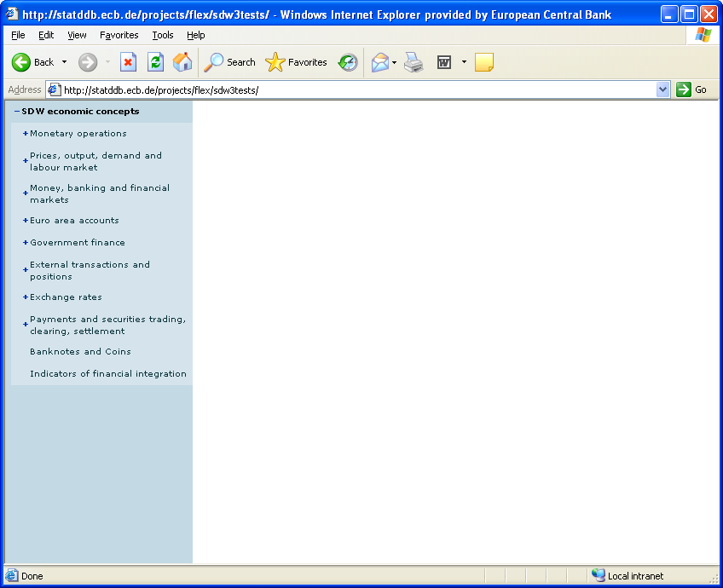

#### Request using the RESTful API

http://ws-entry-point/categoryscheme/[ECB/SDW_ECON](http://ws-entry-point/CategoryScheme/?detail=ReferenceStubs)?references=categorisation

Note: Using the references attribute with a value of “categorisation”, the categorisations used by the category scheme will also be returned and these will contain references to the dataflows attached to the categories.

#### Request using the SOAP API

<query:CategorySchemeQuery referenceResolution=”Shallow”>

<query:References>

<query:Default/>

</query:References>

<query:CategorySchemeWhere>

<query:ID>SDW_ECON</query:ID>

<query:AgencyID>ECB</query:AgencyID>

</query:CategorySchemeWhere>

</query:CategorySchemeQuery>

Note: For the sake of clarity, the SOAP envelop has been omitted.

#### Response

An SDMX-ML Structure message containing the category schemes, as well as the categorisations with references to the dataflows will be returned. The structure of the SDMX-ML Structure message will be as follow (root element, header and repeated elements omitted for the sake of clarity):

<structure:Structures>

<structure:CategorySchemes>

<structure:CategoryScheme>

</structure:CategoryScheme>

</structure:CategorySchemes>

<structure:Categorisations>

<structure:DataflowCategorisation>

</structure:DataflowCategorisation>

</structure:Categorisations>

</structure:Structures>

### STEP 2: Selecting a dataflow

#### Use case

Once a subject-matter domain and a dataflow have been selected, a filter box needs to be populated, to allow users to select data. In order to only create queries for data that actually exist in the database, the dataflow constraints will also be requested.

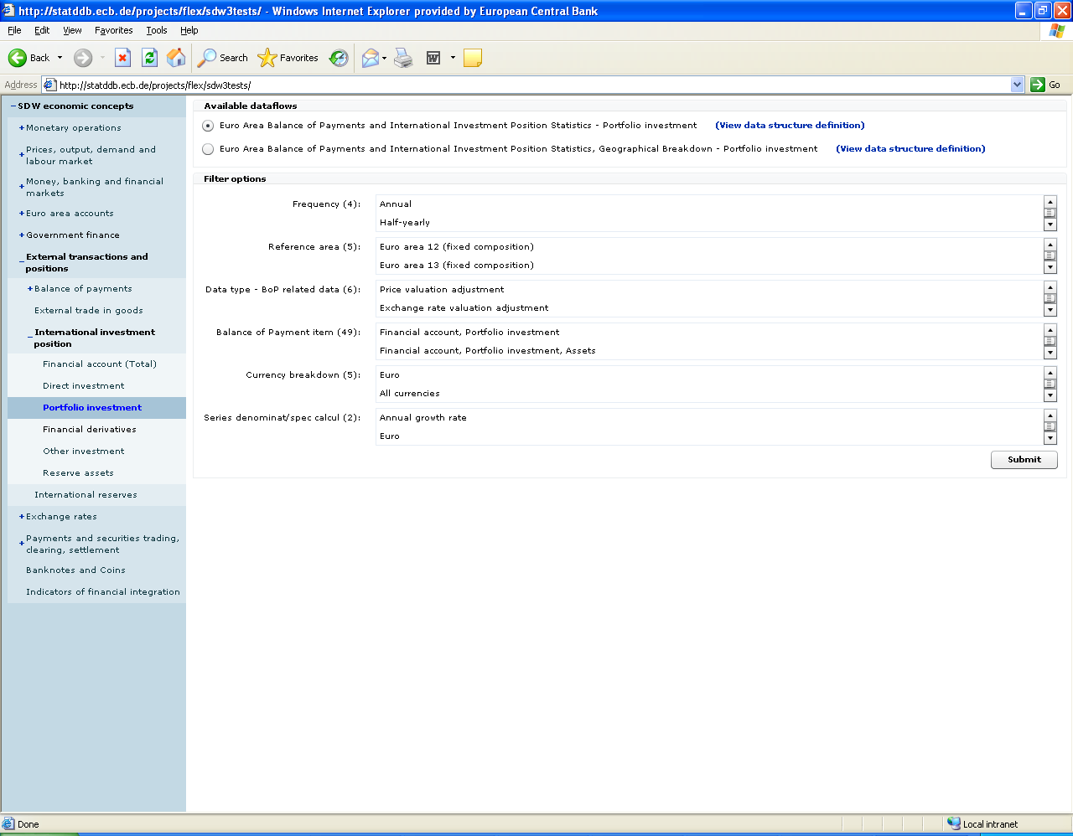

#### Request using the RESTful API

In this sample query, the dataflow id is 123456, the agency id is ECB and the version is 1.2. Using the references attribute, the data structure definition and the constraints will also be returned.

http://ws-entry-point/dataflow/ECB/123456/1.2?references=all

#### Request using the SOAP API

<query:DataflowQuery>

<query:References>

<query:Default/>

</query:References>

<query:DataflowWhere>

<query:ID>123456</query:ID>

<query:Version>1.2</query:Version>

<query:AgencyID>ECB</query:AgencyID>

</query:DataflowWhere>

</ query:DataflowQuery>

#### Response

An SDMX-ML Structure message containing the requested dataflow, as well as the data structure definition and the dataflow constraints attached. The structure of the SDMX-ML Structure message will be as follows (root element and header omitted):

<structure:Structures>

<structure:Dataflows>

<structure:Dataflow>

</structure:Dataflow>

</structure:Dataflows>

<structure:Codelists>

</structure:Codelists>

<structure:Concepts>

</structure:Concepts>

<structure:DataStructures>

</structure:DataStructures>

<structure:Constraints>

<structure:ContentConstraint>

</structure:ContentConstraint>

</structure:Constraints>

</structure:Structures>

If, before selecting data, the user wants to review the data structure definition used by the dataflow, this can be done without sending an additional query, as this information has already been included in the response.

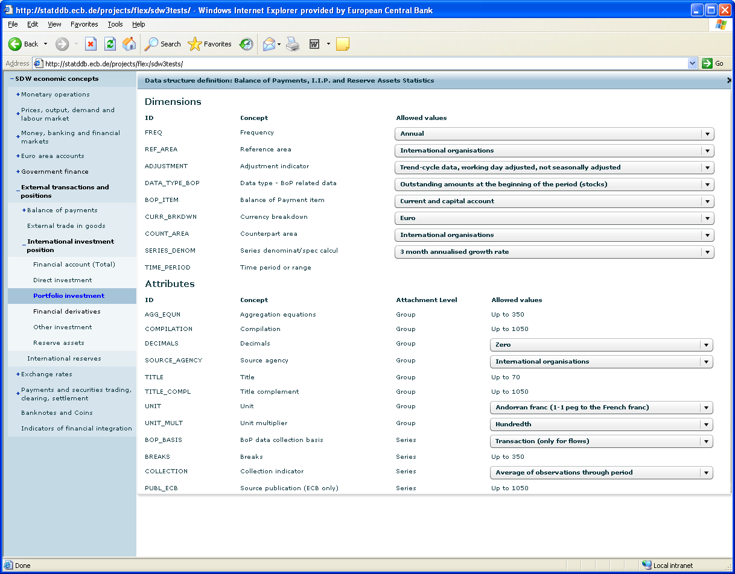

### STEP 3: Data selection

#### Use case

The user uses the dimension filters, to retrieve the data he is interested in.

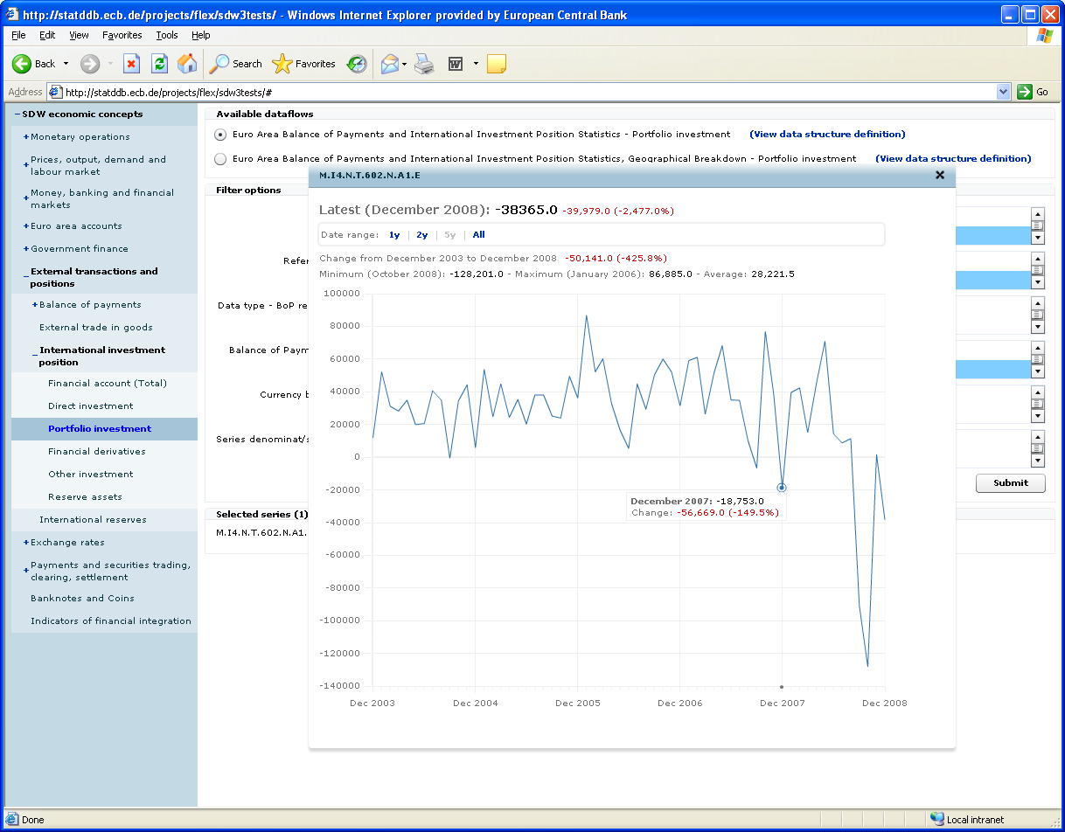

#### Request using the RESTful API

http://ws-entry-point/data/123456/M.I4.N.9.339+340+341.N.A1.A/ECB?startPeriod=2009-01&endPeriod=2009-12&detail=dataonly

Note: Apart from the dataflow id (123456), the data provider is set to ECB, and the series key uses the OR operator for the 5th dimension. Furthermore, only data for 2009 should be returned. As the purpose of the returned data is to be displayed on a graph, the detail level is set to data only. Therefore, attributes and groups will be excluded from the returned message. Regarding the references to the dataflow, the short form is used, as, for this particular web service, the dataflow id and the data provider id are sufficient to uniquely identify the dataflow and the data provider respectively. Should this not be the case, the full reference must be supplied (for example, ECB+123456+1.2 instead of 123456).

#### Request using the SOAP API

<query:Query>

<query:DataWhere>

<query:DataProvider>

<common:OrganisationSchemeRef>

<common:AgencyID>ECB</common:AgencyID> <common:ID>DataProviderScheme</common:ID>

</common:OrganisationSchemeRef>

<common:DataProviderRef>

<common:ID>ECB</common:ID>

</common:DataProviderRef>

</query:DataProvider>

<query:StructureUsage>

<common:DataflowReference>

<common:Ref>

<common:AgencyID>ECB</common:AgencyID>

<common:ID>123456</common:ID>

<common:Version>1.2</common:Version>

</common:Ref>

</common:DataflowReference>

</query:StructureUsage>

<query:DimensionValue>

<query:ID>FREQ</query:ID>

<query:Value>M</query:Value>

</query:DimensionValue>

<query:DimensionValue>

<query:ID>REF_AREA</query:ID>

<query:Value>I4</query:Value>

</query:DimensionValue>

<query:DimensionValue>

<query:ID>ADJUSTMENT</query:ID>

<query:Value>N</query:Value>

</query:DimensionValue>

<query:DimensionValue>

<query:ID>DATA_TYPE_BOP</query:ID>

<query:Value>9</query:Value>

</query:DimensionValue>

<query:DimensionValue>

<query:ID>CURR_BRKDWN</query:ID>

<query:Value>N</query:Value>

</query:DimensionValue>

<query:DimensionValue>

<query:ID>COUNT_AREA</query:ID>

<query:Value>A1</query:Value>

</query:DimensionValue>

<query:DimensionValue>

<query:ID>SERIES_DENOM</query:ID>

<query:Value>A</query:Value>

</query:DimensionValue>

<query:TimeDimensionValue>

<query:ID>TIME_PERIOD</query:ID>

<query:TimeValue operator="GreaterThanOrEqualTo">2009-01</query:TimeValue>

<query:TimeValue operator="LessThanOrEqualTo">2010-12</query:TimeValue>

</query:TimeDimensionValue>

<query:Or>

<query:DimensionValue>

<query:ID>BOP_ITEM</query:ID>

<query:Value>339</query:Value>

</query:DimensionValue>

<query:DimensionValue>

<query:ID>BOP_ITEM</query:ID>

<query:Value>340</query:Value>

</query:DimensionValue>

<query:DimensionValue>

<query:ID>BOP_ITEM</query:ID>

<query:Value>341</query:Value>

</query:DimensionValue>

</query:Or>

</query:DataWhere>

</query:Query>

#### Response

An SDMX-ML Generic data message containing the requested time series.

The structure of the SDMX-ML Data message will be as follows (root element and header omitted):

<message:DataSet>

<generic:Series>

</generic:Series>

</message:DataSet>

## Sample Error Element in an SDMX message

<xs:element name="Error" type="ErrorType">

<xs:annotation>

<xs:documentation>Error is used to communicate that an error has occurred when responding to a request in an non-registry environment. The content will be a collection of error messages.

</xs:documentation>

</xs:annotation>

</xs:element>

<xs:complexType name="ErrorType">

<xs:annotation>

<xs:documentation>ErrorType describes the structure of an error response.

</xs:documentation>

</xs:annotation>

<xs:sequence>

<xs:element name="ErrorMessage" type="common:StatusTextType" maxOccurs="unbounded">

<xs:annotation>

<xs:documentation>ErrorMessage contains the error message. It can occur multiple times to communicate message for multiple errors, or to communicate the error message in parallel languages. If both messages for multiple errors and parallel language messages are used, then each error message should be given a code in order to distinguish message for unique errors.

</xs:documentation>

</xs:annotation>

</xs:element>

</xs:sequence>

</xs:complexType>

## Soap Fault example

<?xml version = "1.0" encoding = "UTF-8" ?>  
<soapenv:Envelope xmlns:soapenv=["http://schemas.xmlsoap.org/soap/envelope/"](http://schemas.xmlsoap.org/soap/envelope/)   
xmlns:xsd=["http://www.w3.org/2001/XMLSchema"](http://www.w3.org/2001/XMLSchema)   
xmlns:xsi=["http://www.w3.org/2001/XMLSchema-instance"](http://www.w3.org/2001/XMLSchema-instance)  
xmlns:sdmxerror="http://www.SDMX.org/resources/SDMXML/webservice/iso/v_2_0_draft/error"

xmlns:sdmxws="http://www.SDMX.org/resources/SDMXML/webservice/iso/v_2_0_draft">   
<soapenv:Body>   
<soapenv:Fault>   
<faultcode>sdmxerror:500</faultcode>   
<faultstring>Internal server error</faultstring>   
<faultactor>sdmxws:GetCodelist</faultactor>   
<detail>   
<sdmxws:composite>   
<sdmxws:code>1028</sdmxws:code>   
<sdmxws:titles>   
<sdmxws:title lang="de">Could not get connection from pool</sdmxws:title>   
<sdmxws:title lang="en">Could not get connection from pool</sdmxws:title>   
<sdmxws:title lang="fr">Could not get connection from pool</sdmxws:title>   
</sdmxws:titles>   
<sdmxws:source>SdmxRegistryService error: could not get connection from pool</sdmxws:source>   
</sdmxws:composite>   
</detail>   
</soapenv:Fault>   
</soapenv:Body>   
</soapenv:Envelope>

1. i.e., the declared namespace of the SDMX WSDL definition.
2. This has been shortened from DataStructureDefinition to allow for shorter URLs.
3. This has been shortened from MetadataStructureDefinition to allow for shorter URLs.
4. The organisationscheme resource can be used whenever the role played by the organisation schemes (e.g. maintenance agencies) is not known/relevant.
5. For 3 of the subtypes of OrganisationScheme (AgencyScheme, DataProviderScheme and DataConsumerScheme), the id and version parameters have fixed values. See Section 03 of the SDMX information model document for additional information.
6. This type can be used to retrieve any type of structural metadata matching the supplied parameters.
7. As “all” is a reserved keyword in the SDMX RESTful API, it is recommended not to use it as an identifier for agencies, resources or a specific version.
8. Default, if parameter not specified
9. This would potentially return more than one artefact, if different agencies give the same identifier to a resource (for example, <http://ws-entry-point/codelist/all/CL_FREQ>, could return more than one codelist if more than one agency is maintaining a codelist with id “CL_FREQ”).
10. The equivalent in SDMX-ML query is: Stub at the query level and Stub at the reference level.
11. The equivalent in SDMX-ML query is: Full at the query level and Stub at the reference level.
12. The equivalent in SDMX-ML query is: Full at the query level and Full at the reference level.
13. It’s a common use case in SDMX-based web services that the flow id is sufficient to uniquely identify a dataflow. Should this not be the case, the agency id and the dataflow version, can be used, in conjunction with the flow id, in order to uniquely identify a dataflow.
14. It’s a common use case in SDMX-based web services that the provider id is sufficient to uniquely identify a data provider. Should this not be the case, the agency can be used, in conjunction with the provider id, in order to uniquely identify a data provider.
15. As “all” is a reserved keyword in the SDMX RESTful API, it is recommended not to use it as an identifier for providers.
16. For additional information, see section 4.2.14 of Section 06 (SDMX Technical Notes).
17. See <http://en.wikipedia.org/wiki/URL_encoding#Percent-encoding_reserved_characters> for additional information.
18. If the information about when the data has been updated is not available at the observation level, the web service should return either the series that have changed (if the information is attached at the series level) or the dataflows that have changed (if the information is attached at the dataflow level).
19. This parameter is useful for cross-sectional data queries, to indicate which dimension should be attached at the observation level.
20. As the query for schema must match one artefact only, the keyword “all” is not supported for agencyId and resourceId.
21. For additional information, please refer to http://www.w3.org/Protocols/rfc2616/rfc2616-sec12.html
22. For additional information, please refer to http://www.w3.org/Protocols/rfc2616/rfc2616-sec14.html
23. For the time being, only version 2.1 is supported as version number.
24. According to the SOAP version Framework 1.2, it is not possible to place both a <faultcode> element and return other information.